Hillier Unveils Design for BBC Gardeners’ World Spring Fair at Beaulieu, 29 April – 1 May 2022
For the second year running Hillier will be headline partner of the BBC Gardeners’ World Spring Fair at Beaulieu in Hampshire, which takes place between 29th April and 1st May 2022, and with it is creating the Hillier Experience.
The Hillier Experience, which proved incredibly popular at the inaugural Spring Fair in 2021, will see two gardening themes merge, offering visitors a true source of garden inspiration for ideas to take home. The spectacular garden display will highlight both a contemporary garden that displays the impact of clean lines and modern influence, and a traditional English garden.
The contemporary garden area will create a sense of movement towards a more modern design, incorporating a focus on outdoor living. Hedging for defined lines and contemporary paving will lead visitors into a social alfresco dining area, decorated with pots containing attractive structural shrubs. The garden will feature a striking display of cloud pruning of various sizes and textures, as well as bright purple alliums to add a splash of colour and fragrance. A thought provoking twist in the formal planting, there will also be a wildflower area and bug hotel to encourage wildlife to a modern space.
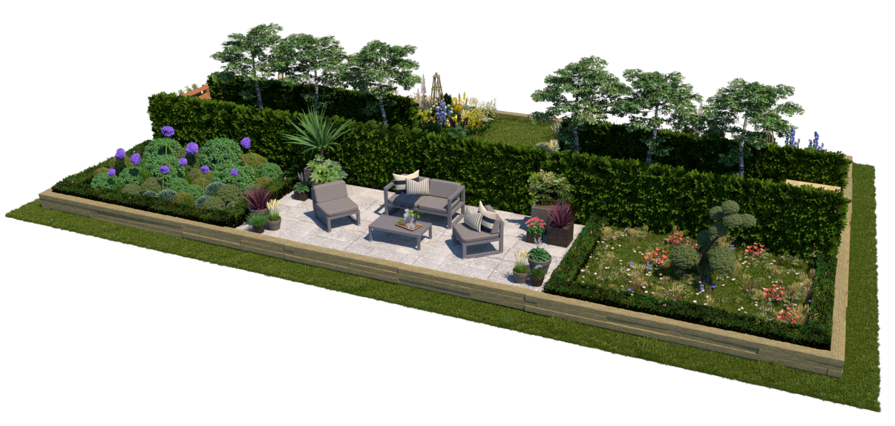

The traditional garden area within the Hillier Experience will reflect upon the distinctive and much-loved old English garden style with vibrant colours and inspiring historical touches. A strikingly colourful herbaceous border will take visitors on a journey of vivacity and scent throughout a rainbow of beautiful flora, with added nods to Gertrude Jekyll’s horticultural influences. A traditional Lutyens bench will form a focal point within the English Garden area, incorporating elements of the arts and crafts movement of Gertrude Jekyll’s and Edwin Lutyen’s time. A range of different shrubs and perennials will give form and shape to the border and will be enticing for bees and butterflies alike. Surrounded by sleepers and clematis plant obelisks, visitors can be truly inspired by the variations of height and constructions providing ideas for their own outdoor space.
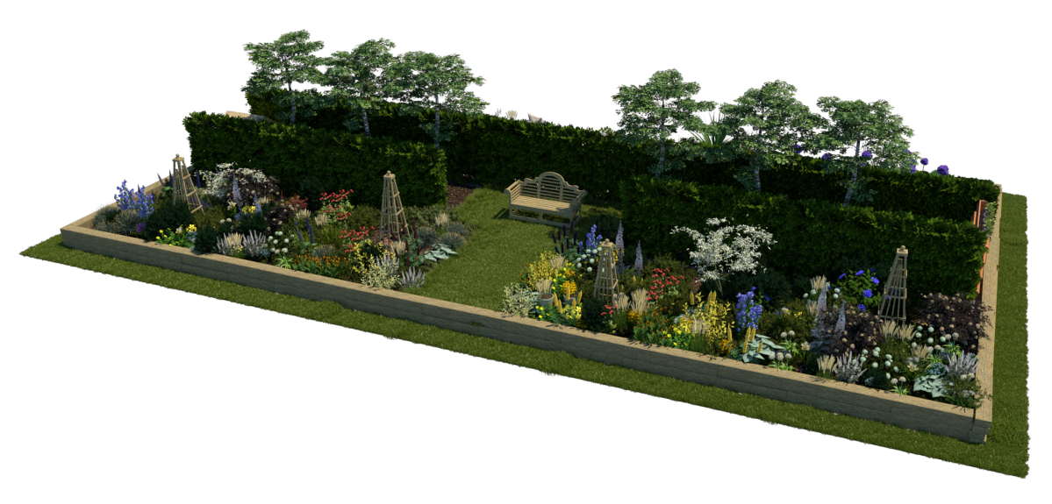

Experts from the Hillier team will also be located around the Hillier Experience, offering tips and advice to visitors, and answering any questions they may have about their own gardens and plants. The retail section of the Hillier Experience will provide an opportunity to buy top-quality plants featured within the garden design all grown peat free and cared for by Hillier’s expert growers on the companies’ nurseries in Hampshire.
There will also be a fantastic opportunity to purchase the newly launched Forsythia x intermedia ‘Discovery’ (JOHN MITCHELL) that has been added to the Hillier collection this year. The introduction of Forsythia x intermedia ‘Discovery’ comes following its discovery 15 years ago in the garden of John Mitchell. Propagated from just a single 15cm twig found on a Forsythia bush and nurtured by the expert growers at Hillier nursery in Romsey, the plant features ovate green leaves, vibrant yellow flowers and a strong supporting structure. It will be a brilliant occasion to purchase this delightful new form that adds striking variegated foliage to the already impressive flowers of this Genus.
As headline partner of the BBC Gardeners’ World Spring Fair, Hillier will offer a vast array of innovation and encouragement to gardeners of all abilities. “We are looking forward to being headline partner at BBC Gardeners’ World Spring Fair for the second year running and to be unveiling new details about our Hillier Experience garden feature,” comments Chris Francis, Wholesale and Retails Director of Hillier. “We have developed many displays throughout our history, but this design is a step forward for us and offers something more diverse, particularly through the contrast of contemporary and traditional themes. We are excited to showcase our Hillier Experience and to meet many gardeners over the course of the Fair, helping to impart our knowledge and inspire garden ideas.”
The BBC Gardeners’ World Spring Fair will take place in the beautiful open grounds of Beaulieu in Hampshire, home of the National Motor Museum and the historical Montagu Home Palace House, from Friday 29th April to Sunday 1st May 2022.
Find out more, and book tickets, at bbcgardenersworldfair.com

ENDS

Notes to Editors
For further media enquiries about Hillier please contact Holly Daulby at Honest Communications.
holly@honestcommunications.co.uk
07961 205812 01332 653693
For further media enquiries about the BBC Gardeners’ World Spring Fair, please contact Sarah Sandys-Renton at Immediate Live.
ssr@immediate.co.uk 07500 762 168
BBC Gardeners’ World Spring Fair licenced by BBC Studios
About Hillier:
“To inspire the creation of green living spaces for now and the future”
Hillier is the most successful exhibitor in the history of the RHS Chelsea Flower Show, having been awarded 74 consecutive gold medals.
The company was founded in 1864 by Edwin Hillier and remains a family-run nursery with the fifth generation now actively involved in the family business as it continues to grow. The company employs over 750 staff across its nursery, amenity trees and 19 garden centre divisions, and grows over one million plants a year. It is the largest tree grower in the UK.
Over the years, Hillier has been responsible for numerous plant introductions, many of which have become essentials in British gardens and it continues with the tradition of innovation and the introduction of new garden plants in the present day.

