Beautiful Borders Competition 2024

Dear Applicant,

We are delighted to be getting in touch to announce the Beautiful Border applications for the 2024 BBC Gardeners’ World Events are now OPEN!
- BBC Gardeners’ World Spring Fair from Friday 3 May – Sunday 5 May 2024
- BBC Gardeners’ World Live from Thursday 13 June – Sunday 16 June 2024
- BBC Gardeners’ World Autumn Fair from Friday 30 August – Sunday 1 September 2024

At just a few square meters, creating a Beautiful Border is a fantastic way to showcase your skills to a large audience of keen gardeners, press and experts. A favourite feature for visitors to the BBC Gardeners’ World Events, the Beautiful Borders display a variety of excellent designs, space savvy ideas, planting combinations and creative features that can be packed into a small garden.

The BBC Gardeners’ World Fair Spring, now in its fourth year and is expected to welcome 23,000 visitors to the beautiful grounds of Beaulieu. The Fair is set amidst the internationally famous National Motor Museum, Palace House and beautiful culinary gardens. As with BBC Gardeners’ World Live, we bring the extremely successful dynamic of gardening and food together at the BBC Gardeners’ World Fairs, in the form of the BBC Good Food Market. The inspirational Beautiful Borders are a central and much-loved feature of the Fair.

The flagship event, BBC Gardeners’ World Live, has been attracting tens of thousands of keen gardeners every year, for over 30 years. The Show is a celebration of summer gardening, and the Beautiful Borders continue to be an annual visitor favourite. The 2023 show boasted over 22 inspiring Beautiful Borders with over half being awarded Platinum or Gold Award and being seen by a over 90,000 visitors over four days.

The second year of the BBC Gardeners’ World Autumn Fair was a hit, welcoming 18,000 visitors to the beautiful grounds of English Heritage’s Audley End House and Gardens in September 2024. The Fair shone with new additions, more experts, a bigger footprint and triple the number of Beautiful Borders and Showcase Gardens compared to the launch event. The Fair encourages exhibitors to present the very best of autumn garden and plant inspiration and featured top experts including Adam Frost, Arit Anderson and Frances Tophill.

Who’s it for?

For the professionals, Beautiful Borders are a fantastic way to display your skills as a garden designer and plantsman, showcasing your business to thousands of people throughout the duration of the shows.

For gardening clubs and charities, the Beautiful Border competition is a creative and engaging way to raise awareness and convey a message to a receptive audience.

For Garden Design and Horticulture students, the Beautiful Borders offer an unbeatable chance to gain experience of designing and building a show garden.

Bursary:

This year we are offering a £200 bursary to selected applicants to go towards plant/prop investment.
Whilst the grants are limited, all applications will be considered on their own merits and applications can still be approved although they may not be selected for grant status. For the Fairs this will be 12 Beautiful Borders per Fair and at BBC Gardeners’ World Live we will be offering the bursary to 25 applicants. Please state in your application if you would like to be put forward for the bursary and we will let you know if you have been successful as soon as possible.

Testimonial:

Cara Thompson, Gold award and People’s Choice winner 2023 said “Putting my design application forward for a BBC Gardeners World Autumn Fair Beautiful Border was one of the best decisions I have made! The whole journey from designing the vision to creating the border has been absolutely incredible.”

Cara continues, “It was my first time ever designing a garden, I have now found a new passion for designing and I’ve learnt so much from this experience. I am incredibly grateful for the opportunity of designing a border which was awarded Gold. I was presented the People's Choice Award from Adam Frost which also made my year! If anyone is thinking about putting an application forward just go for it!”

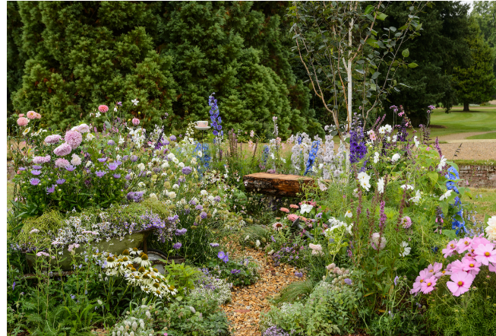

Theme: ‘Share my Space’

We invite you, garden designers and creators, to share your space by designing a Beautiful Border at one of the BBC Gardeners’ World Events in 2024. The ‘Share my Space’ theme is all about harnessing the potential of small garden spaces and using them as catalysts for building a sense of community through gardening.

Your interpretation of the ‘Share my Space’ theme might be your ideal quiet oasis, your gardening workshop, a space to share with your family and friends or even a trip down memory lane. Your Beautiful Border can be a true masterpiece, demonstrating that size is no barrier to beauty or functionality. Our gardens, no matter how big or small, are spaces we can come together, learn from one another and cultivate a shared green oasis. Whether it’s growing vegetables, nurturing pollinators, or simply enjoying fresh air, your Beautiful Border will reflect a creative use of space while inspiring others to make the most of their own gardens. Limited in size but bursting with potential!

Awards:

As well as the prestigious Platinum, Gold, Silver Merit, Silver and Bronze Awards to acknowledge excellence within the competition, the Borders Assessment Panel award the Best Beautiful Border, Best Interpretation of the Theme and Best BBC Gardeners’ World Magazine Subscriber Border – all of which offer recognition to the most outstanding entries.

Beautiful Border assessor, Ian Hodgson (Editor, Garden News) said “I really enjoy the whole process surrounding the Beautiful Borders competition, working with the team, meeting the creators, and hearing how they translated their vision into reality.”

“It’s also heartening to appreciate how those representing charities are trying to contribute to making the world a better place via their exhibits, and to hear about those who are setting out on a career in design. Beautiful Borders give them such an important step forward.”

Apply now!
Applying is quick and easy, please complete the attached application. Should you have any questions or issues regarding the application, please feel free to get in touch.

We hope that you will see this as a great opportunity to participate in the BBC Gardeners’ World Events. Once we have received your application, we endeavour to get back to you with 21 days. The deadline to return applications are:

- BBC Gardeners’ World Spring Fair: 23 January 2024
- BBC Gardener’s World Live: 23 January 2024
- BBC Gardeners’ World Autumn Fair: 2 May 2024

We look forward to hearing from you!

Lucy Tremlett
Head of Horticultural Division

Contact details:
Lucy Tremlett:
E: Lucy.Tremlett@immediate.co.uk
T: 0207 1505130

Beautiful Borders

Please complete the below form and return as soon as possible to Lucy Tremlett either by post or by email.
Allocation of space will be confirmed within 21 days of receipt of application, however the deadline to return applications is as follows:

- BBC Gardeners’ World Spring Fair: 23 January 2024
- BBC Gardener’s World Live: 23 January 2024
- BBC Gardeners’ World Autumn Fair: 2 May 2024

Lucy Tremlett
Immediate Live
44 Brook Green
Hammersmith
London W6 7BT

Lucy.Tremlett@immediate.co.uk

Thank you and we look forward to working with you!
Lucy Tremlett
BBC Gardeners’ World Events Horticultural Show Team

CHECKLIST

Please tick below which show you wish to submit your application form for:

☐ BBC Gardeners’ World Spring Fair 2024

☐ BBC Gardeners’ World Live 2024

☐ BBC Gardeners’ World Autumn Fair 2024

Please make sure your completed form is returned with the below documents:

☐ Master Plan

☐ Perspective drawing (Please note this will be used on the website, signage and in show comms)

☐ 50-100 word description for use in the Show guide, on-site signage and PR purposes

☐ Any other relevant details for example; sculpture, water etc.

☐ Preliminary planting plan with key structural specimens

CONTACT DETAILS

Exhibitor Contact Details
These details are used for communication between the Show Team and the Exhibitor and will not be published:

Company (if applicable)
Key Contact
Address
Post Code
Email
Telephone | Mobile | Landline
Web Address
Are you a subscriber to BBC Gardener’s World Magazine? | ☐ Yes ☐ No
Social Media Handles (as applicable) | Facebook:  Instagram:  LinkedIn:  Twitter:

Beautiful Borders Design Details
Designer’s Name
Company/Organisation/College
(if applicable)
Title of Border
The theme for 2024 will be:

‘Share my Space’

Please write a short story or design explanation (50-100 words)
Please use separate sheet if necessary.

There will be two sizes of border available to plant, please indicate below which you would prefer (please note, these diagrams are not to scale). The below measurements indicate the estimated planting area of the border. You are also welcome to suggest any of the variations of the sizes, we can put two borders together or add meterage within the below multiples:
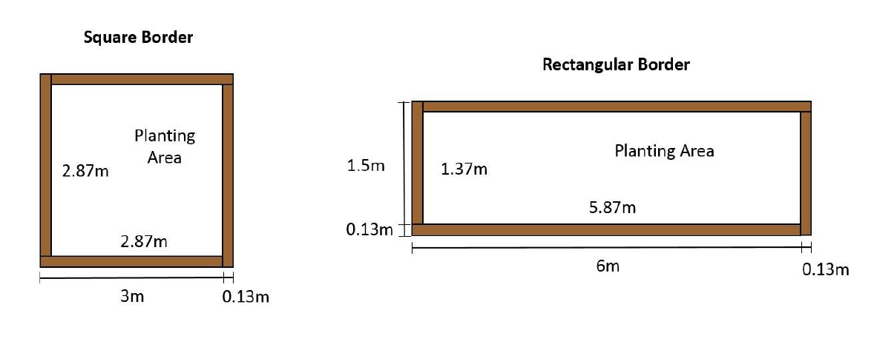

1.24m
2.74m
2.74m
5.74m

☐ Square Border ☐ Rectangular Border
Note: If you feel your project might better suit a larger space contact Lucy Tremlett about our Showcase applications (small garden size of up to 40m2, like Show Gardens these are subject to individual themes)

Will you be selling off the plants in your border in the Sunday evening sell-off (from 16.00)?
☐ Yes
☐ No

FINAL CHECKLIST
Here is a final summary of the actions you need to take and all forms that need to be completed with your application, before sending this form and associated documents to lucy.tremlett@immediate.co.uk.

- Have you ticked which show you are submitting your application for?

- Have you completed all relevant parts of this form?

- Have you enclosed all the documents outlined within the first checklist?

- Saved a copy of these files for your own reference?

On acceptance of application, detailed requirements along with an outline of the rules and regulations will be discussed.

In submitting this application, I/we confirm that if this application is successful I/we will comply with the schedule set out in the BBC Gardeners’ World Events Manual 2024 and have read and understood all enclosed documents.

Signed: _________________________________________

Date: _____________

Allocation of space will be confirmed within 21 days of receipt of application, however the deadline to return applications is as follows:

- BBC Gardeners’ World Spring Fair: 23 January 2024
- BBC Gardener’s World Live: 23 January 2024
- BBC Gardeners’ World Autumn Fair: 2 May 2024

