Showcase Garden Application
13th – 16th June 2024

Please complete the below form and return at your earliest convenience to Lucy Tremlett either by post or by email and we will consider your application and give a decision in three weeks. The latest date that applications will be accepted will be Monday 22nd January 2024.

Lucy Tremlett
Immediate Media
Vineyard House
44 Brook Green
Hammersmith
W6 7BT

Lucy.Tremlett@immediate.co.uk
Please note that emails larger than 10MB will be rejected by the server so please use another method such as Drop Box or WeTransfer.

SHOWCASE GARDENS

Showcase Gardens offer designers a step up from Beautiful Borders or provide a good starting point for any Show Garden enthusiasts. The showcase gardens are restricted to below 40m2, but not limited by any theme to allow for creativity and artistry. The Showcase Gardens will be assessed with specific criteria that differs from the Show Gardens and are a fantastic opportunity for those looking for a bigger challenge!
The Gardens do not carry a specific theme.

Meet the Team:
Bob Sweet – Horticultural Director
Bob brings a vast amount of knowledge and familiarity with running shows and will advise on any aspects of the horticultural content.

Lucy Tremlett – Horticultural Event Manager
Lucy manages the event and is your first point of contact should you have anything you would like to discuss. She will be available on lucy.tremlett@immediate.co.uk

Imogen Grundy – Horticultural Executive
Imogen works alongside Lucy on the content of the show and will be available to answer any queries. She will be available on imogen.grundy@immediate.co.uk

Sarah Sandys-Renton – Brand and Marketing Manager
Sarah, and her team, will coordinate all marketing elements of the show including the Show Gardens. This means she may be in touch with any questions about your submission but if you have anything to share with her, please do on ssr@immediate.co.uk

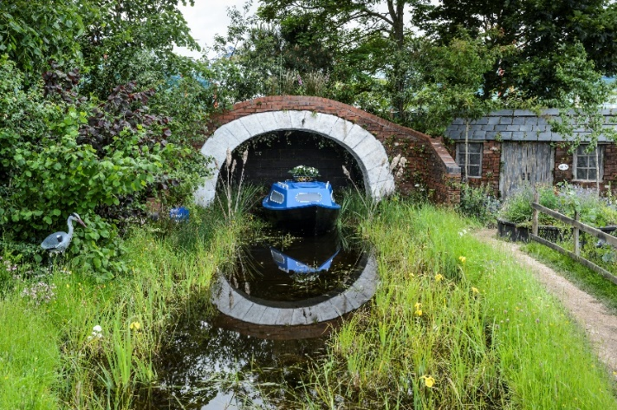
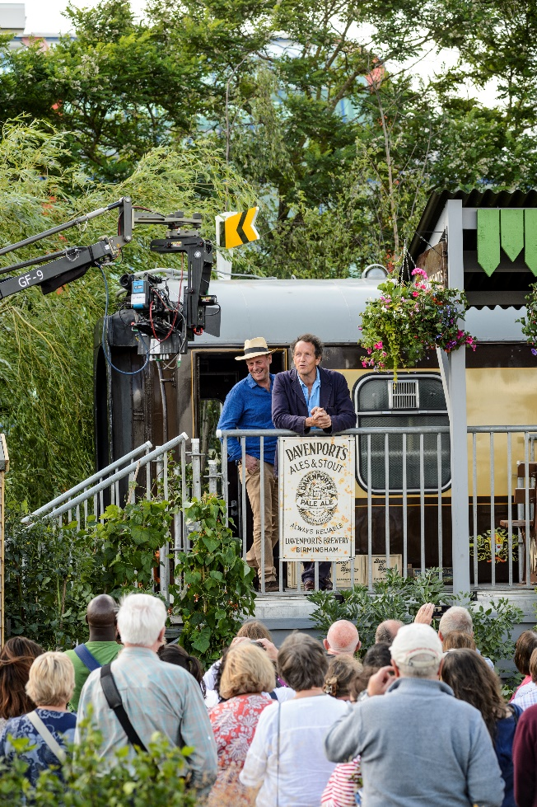

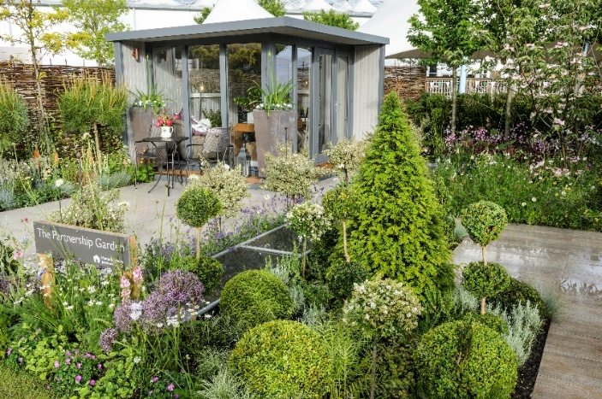

CHECKLIST

Please make sure your completed form is returned with the below documents:

☐ 100-150 design explanation – this should include the inspiration and story behind your design, along with the title of the garden.

☐ Scale plan of your garden – showing the garden from above, to scale and with measurements and key. Please also make sure you indicate the sides which you would like the garden viewed from.

☐ A perspective drawing – showing a view into the garden

☐ Elevations plan with details of excavations – showing key excavation depths and elevation heights

☐ Preliminary planting plan with key structural plants – this does not need to be definitive as we understand that plants may need to be changed through the build up to the show.

☐ Any other relevant details for example; buildings, sculpture, water etc.

Depending upon your design, we may require you to send through the following after receiving your application:

☐ Elevations plan with details of excavations – showing key excavation depths and elevation heights
CONTACT DETAILS

Designer’s Details
These details are used for communication between the Show Team and the Exhibitor and will not be published:

Company
Key Contact
Address
Post Code
Email
Telephone | Mobile | Landline
Web Address

Contractor Details

Contractors Company Name
Contact Name
Contractors Address
Post Code
Email
Telephone | Mobile | Landline
Web Address

Sponsor’s Details (if applicable)

Sponsor’s Name
Contact Name
Sponsors Address
Post Code
Email
Telephone | Mobile | Landline
Web Address
DESIGNER’S SHOW HISTORY/BACKGROUND

Show and year at which the designer has designed a Show Garden along with the medal awarded:
Show & Year | Garden Title | Medal

If you have not designed a Showcase Garden yet, please list any relevant background, experience, and qualifications:

CONTRACTOR’S SHOW HISTORY
Show and year at which the contractor has designed a Show Garden along with the medal awarded:
Show & Year | Garden Title | Medal

SHOW GARDEN DETAILS AND REQUIREMENTS
Please note this is your initial garden brief, we understand elements of this might change on the run up to the show and will ask for a new brief 2-4 weeks out. The new one will then be shared with the assessment team and you will also have opportunity pre-assessment to update on any changes.

Show Garden Title
Show Garden Design Explanation (100-150 words)

Show Garden

Preferred Dimensions:

Depth (front to back) _________m

Frontage (left to right) _________m

Diameter (if circular) _________m

Do you intend to excavate (for pools, foundations etc.)?
☐Yes
☐No

If Yes, please answer the following questions
- To what depth _________mm

- How many tonnes of soil will need displacing (approx.)? _________tonnes

- Will this soil be incorporated back into your garden? Where possible we may be able to help with the excavations for your garden.
☐Yes
☐No
SHOW GARDEN COST ESTIMATE

Name of person completing the form
Company
Representing (i.e. exhibitor name) if different from above

This information is required to demonstrate that the costings below are realistic with regards to the materials and plants specified in your design and the associated build costs.
N.B. this information will remain confidential between applicant and the organiser.

Item | Costs (£)
Excavations | Please note, we have onsite plant which will take care of your excavation and will be onsite throughout the build. Unloading and moving pallets is also included with the onsite plant. There is no cost to you associated with this.
Hard Landscaping – paths, foundations etc. | We are working with Marshalls who are happy to donate free of charge any materials from their domestic range towards each garden.
Water & Electrics | There is no charge for water onsite.  There is no mains electrics during the build, so gardens will need to bring generators. However, if you require electrics for the show open, this is possible but there is a charge involved.
Buildings
Boundary walls, screens etc.
Features, including statuary
Plants & planting materials
Labour
Plant & Machinery
Finishing touches (this should include rope and post) | We are working with Rolawn who are happy to donate free of charge their lawn and any topsoil from their range towards each garden.
Clearance of site | Each garden will be asked for a £400 refundable deposit which will be returned to the exhibitor upon inspection and sign-off of the site. The Show Organisers will arrange grab lorries and skips for all gardens and will minus from the deposit the agreed cost for the amount of skips/grab lorries that the garden requires.
Transport
Accommodation
Printed information- leaflets, brochures, plant lists etc.
Fees
Other
Contingency
TOTAL | £

FINAL CHECKLIST

Here is a final summary of the actions you need to take and all forms that need to be completed with your application, before sending this form and associated documents to lucy.tremlett@immediate.co.uk.

- Have you completed all relevant parts of this form?

- Have you enclosed all the documents outlined within the first checklist?

- Saved a copy of these files for your own reference?

On acceptance of application, detailed requirements along with an outline of the rules and regulations will be discussed.

In submitting this application, I/we confirm that if this application is successful I/we will comply with the schedule set out in the BBC Gardeners’ World Live Manual and have read and understood all enclosed documents.

Signed: _________________________________________

Date: _____________

Please return this form no later than Monday 22nd January 2024.

