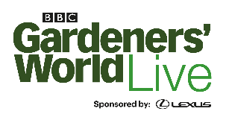
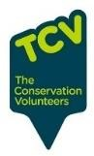

Health for Life SCHOOLS’ WHEELBARROW COMPETITION

APPLICATION FORM
Please complete this application form to confirm that your school plans to enter the
Wheelbarrow competition at BBC Gardeners’ World Live.
Please return completed forms to aneesah.davies94@tcv.org.uk by 28 February 2024 if your school would like to take part. If you have any queries, please call Aneesah on 07801686019.

School name
Address, including postcode (this will be used for collection and returning of the wheelbarrow).
Tick as appropriate | □ Nursery □ Primary □ Secondary
Contact name #1 Email
Phone
Contact name #2 Email
Phone

Key timings
- This application form – return by 28 February 2024 to aneesah.davies@tcv.org.uk
- Briefing session – 6th March, 4.00 to 5.30pm, at Winterbourne House and Garden, with collection of barrows and briefing/tips
- Plant list and rationale for choice related to food and climate change (see notes) – by 2nd May to aneesah.davies@tcv.org.uk
- Barrow collection – TBC
- Show dates –13th to 16th June 2024
- Return of barrows- TBC
Using the details supplied above, we’ll keep in touch re key dates, tickets to the show, signage and plant list requests, and any other details as they arise.
Thank you and good luck!
From the BBC Gardeners’ World Live team

