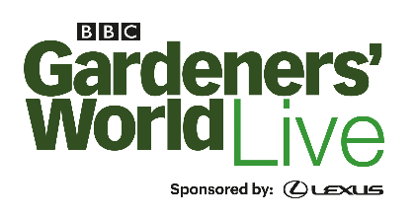

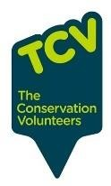
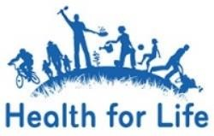
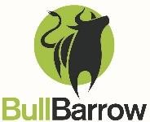

BBC Gardeners’ World Live 2024
Health for Life Schools Wheelbarrow Competition: Food and Climate Change

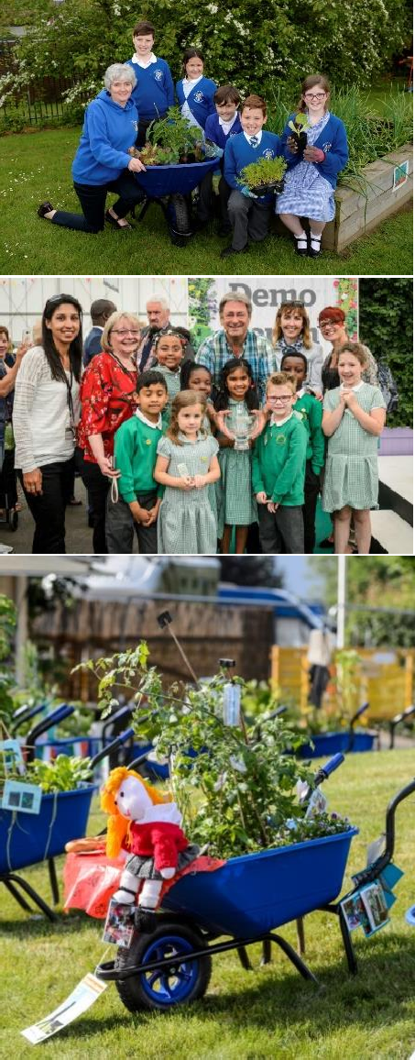
Welcome to BBC Gardeners’ World Live 2024 Health for Life schools’ wheelbarrow competition which is an exceptionally popular annual feature at the show. This is an exciting opportunity for your school to show off pupils’ creative flair with the satisfaction of seeing your final creations on display at the show, enjoyed by tens of thousands of visitors.
The competition is a simple, hands-on and fun gardening activity that can be enjoyed by pupils of all levels, from nursery to secondary. Pupils, with teachers’ support, will need to decide on an idea to fit the theme, design the barrow and then plant, nurture and care for the plants until the barrow is collected for display in June.
This year’s theme is ‘Food and Climate Change’. Entry is free and each participating school will:
- be invited to send a member of staff to a briefing session in March
- be provided with a barrow which the school can keep, after the show, for future use
- be given up to eight complimentary tickets for the show with the opportunity to purchase additional tickets
- receive a certificate with a judgment score for the school’s barrow as well as having the potential to win an award for best in show (nursery, primary, secondary, people’s choice)
Please note that due to the nature of this competition (specifically the collection/delivery of barrows) it is open to Health for Life schools in Birmingham only.

Your main contact for the competition is Aneesah Davies, aneesah.davies@tcv.org.uk, or on 07801686019.

THE THEME – Food and Climate Change

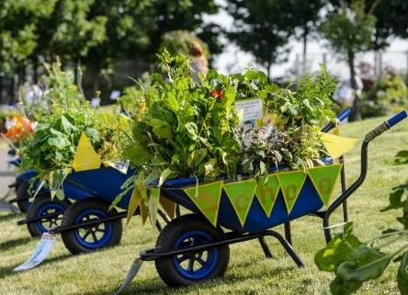
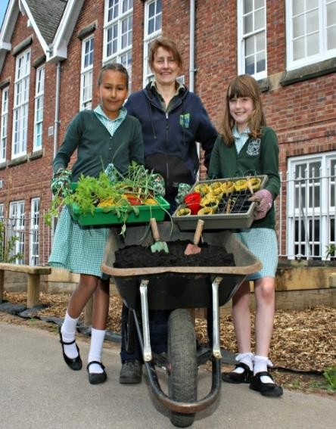
The concept for this year’s wheelbarrow competition is food and climate change. Schools are encouraged to think about the many
different ways that climate and environmental changes are affecting food production (both globally and at local level); choose an
aspect that interests pupils and decide how to interpret this in designing and planting a barrow to show how the particular problem
might be reduced.

A few examples of issues, potential solutions and how this might be represented in a barrow are given below but this is
not an exhaustive list. Pupils can be as imaginative as they like, carry out research and have fun reflecting their own ideas.
Teachers may also want to think about making links with curriculum topics and / or relate to what they are already doing as part of
the school’s Health for Life growing activities.

Issue | Possible mitigation / solutions | Barrow planting ideas
Food miles | Growing food locally and using seasonal produce to reduce carbon footprint | Grow a variety of seasonal vegetables and herbs – perhaps explain how they can be used to create a tasty meal or link to freezing/making jams, pickles (to prolong availability for certain seasonal produce)
Sustainability | Encouraging insect pollination  which is essential for food production and can improve yield and quality | Grow a mix of vegetables and flowers which will attract bees and other pollinators – perhaps include a bug hotel
 | Cultivating high yielding plants for the space available | Select plants which grow well in a small space and produce multiple fruits which can be picked throughout the season
Water shortages | Consider water saving and irrigation methods and focusing on food crops which are drought-resistant | Grow a mix of vegetables and herbs which can withstand drier conditions. - perhaps represent or mention other aspects e.g. mulching the soil, water saving devices etc.

Details of the rationale behind the planting idea, and how this relates to the theme, will need to be submitted before the show and
will form part of the judging of the wheelbarrow.

Schools are encouraged to grow plants from seeds or cuttings where possible. The barrow design can be supported by the creative use of props but please remember these props will need to be robust and properly secured to withstand transportation and weather conditions at the show.

APPLICATION PROCESS AND KEY DATES

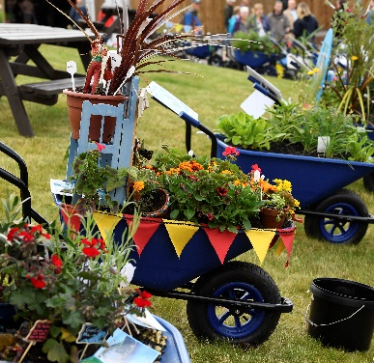
- Applications: by 28th February 2024. Register your interest with aneesah.davies@tcv.org.uk using the application form

- Briefing session: 6th March, 4.00 - 5.30pm at Winterbourne House and Gardens, University of Birmingham, 58 Edgbaston Park Road, Edgbaston, Birmingham B15 2RT. The briefing will include hints and tips around the theme and best planting results and will include all show information. Representatives from the schools will be sent a map of location beforehand and can collect their wheelbarrow AT THE SESSION

- Submission of barrow details: 2nd May 2024, please submit the following to aneesah.davies@tcv.org.uk, which will be published on your signage at the Show and also contribute to the judging of the barrow
- Your plant list
- Rationale for your choice of plants and short explanation as to how this relates to a specified aspect of food and climate/ environmental changes

- Barrow collection: TBC

- The Show: open from 13th – 16th June inclusive

THE AWARDS

There are four awards available for the highest scoring wheelbarrows at the show:
- Best Nursery Wheelbarrow
- Best Primary Wheelbarrow
- Best Secondary Wheelbarrow
- Public Choice (announced at the end of the Show, based on the public vote during the show open days)

As well as the above awards, we will be awarding each participating school with a certificate, with a rating out of a possible five stars for their wheelbarrow entry.

Wheelbarrows will be judged on the following criteria:
- Plant selection
- Rationale explaining reasoning behind the selection, related to food and climate/environmental changes
- Visual impact

The assessment panel is to be confirmed at the later date.

ADDITIONAL NOTES

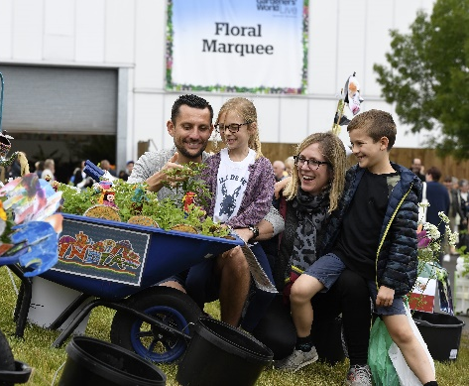
Each school will be given up to eight complimentary tickets for the school setting, with the opportunity to purchase additional tickets.

The Conservation Volunteers (TCV) will take responsibility for the upkeep of the wheelbarrows at the Show.

You can contact the Show’s Marketing & PR team at any time with interesting stories, photos or news about your entry which
could be used in the Show’s social media or in PR activity. Please email Sarah on ssr@immediate.co.uk

Please note that due to the nature of this competition (specifically the collection/delivery of barrows) it is open to Health for Life schools in Birmingham area only.

We cannot wait to see the creativity of your pupils in translating the theme into the school’s barrow.
Please get in touch with any queries as we’re here to help. Contact Aneesah on 07801686019 aneesah.davies@tcv.org.uk
We hope you enjoy growing together.

GOOD LUCK!!

